Computer Language Coding Concepts

Execution Object Redirection in a Diagram
The concept of execution object redireciton is explained in the article Execution Object Redirection. The current article explains its expression in a diagram.

Even though it is not allowed to use an execution object redirection, its usage only creates a warning and alternate behavior. You will be able to see an execution object redirection in a diagram, but it will be marked with a warning and have the behavior of an execution class redirection.

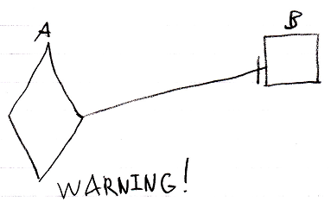

Refer to the article Execution Class Redirection in a Diagram for an explanation of the behavior and the meaning of the diagram above.

See also: Execution Object Redirection,
Execution Class Redirection in a Diagram,
Commands

Author & Copyright: Jan-Joost van Zon Date: August 10, 2008 – August 10, 2008 Location: Oosterhout, The Netherlands Status: Finished

